**Phase3-Practice Project: Assisted Practice**

**JMeter:**

**User defined variables:**

Add thread group

Then add recording controller in thread group

Then record the script

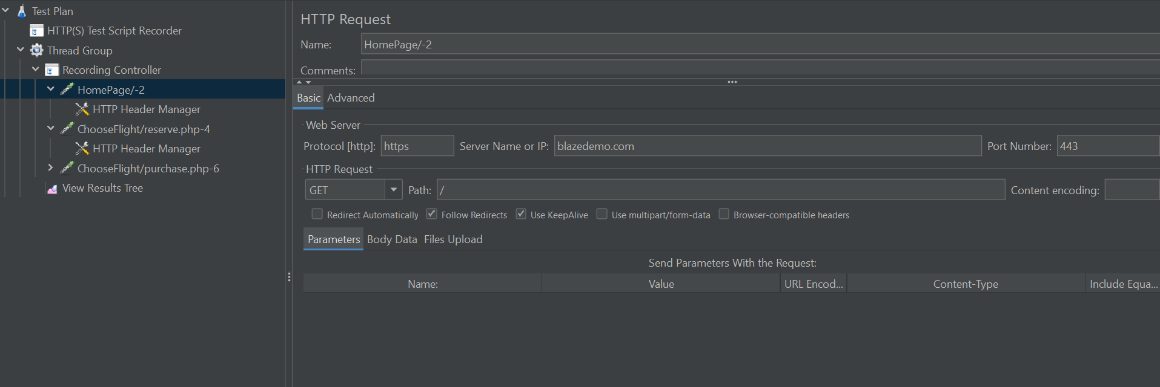

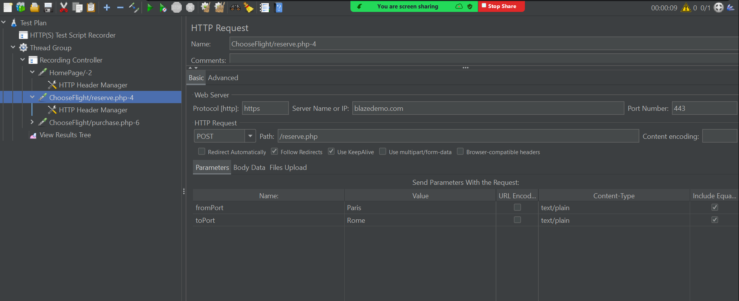

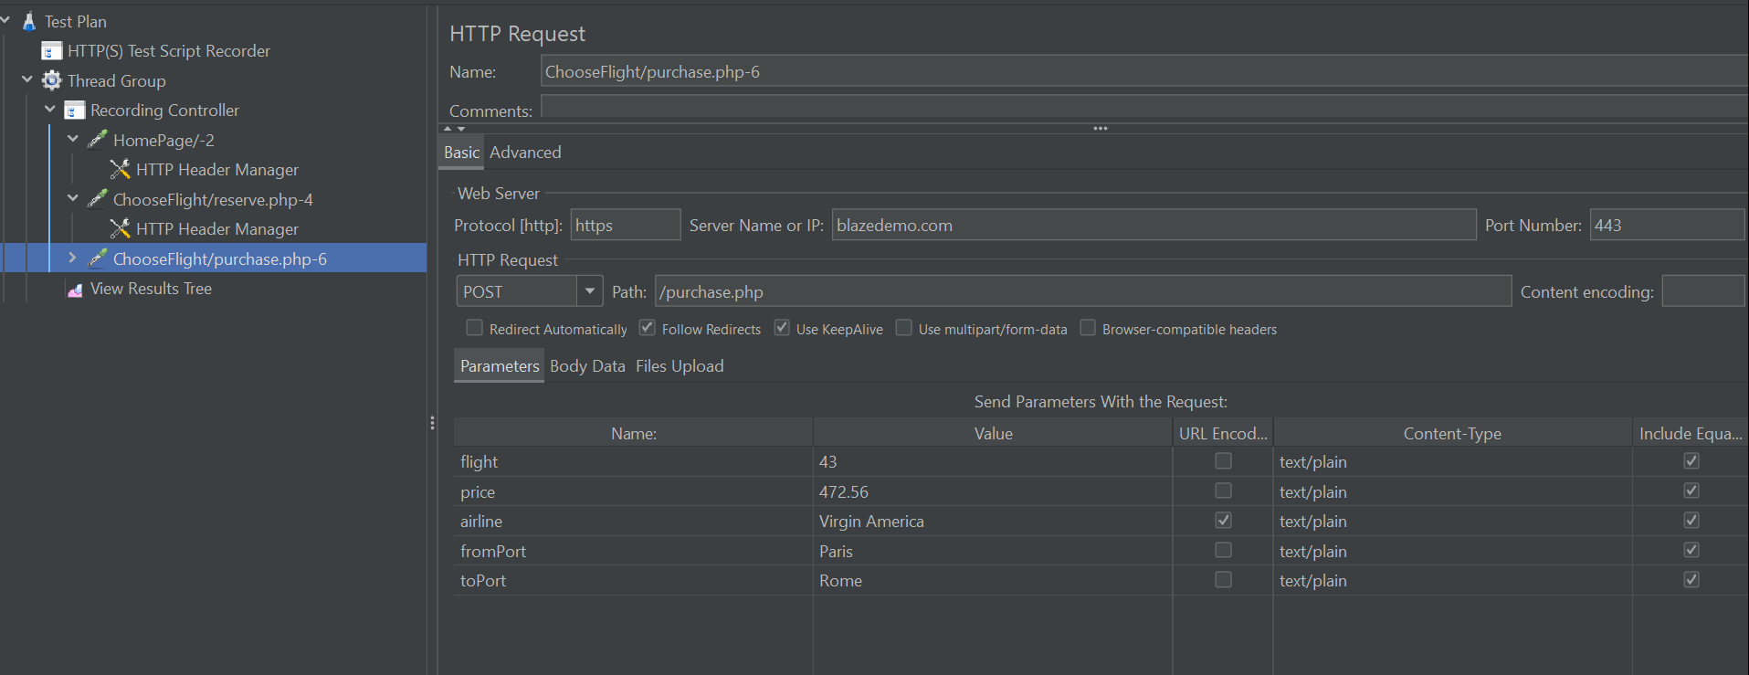

Add to the thread group a config element-> user defined variables

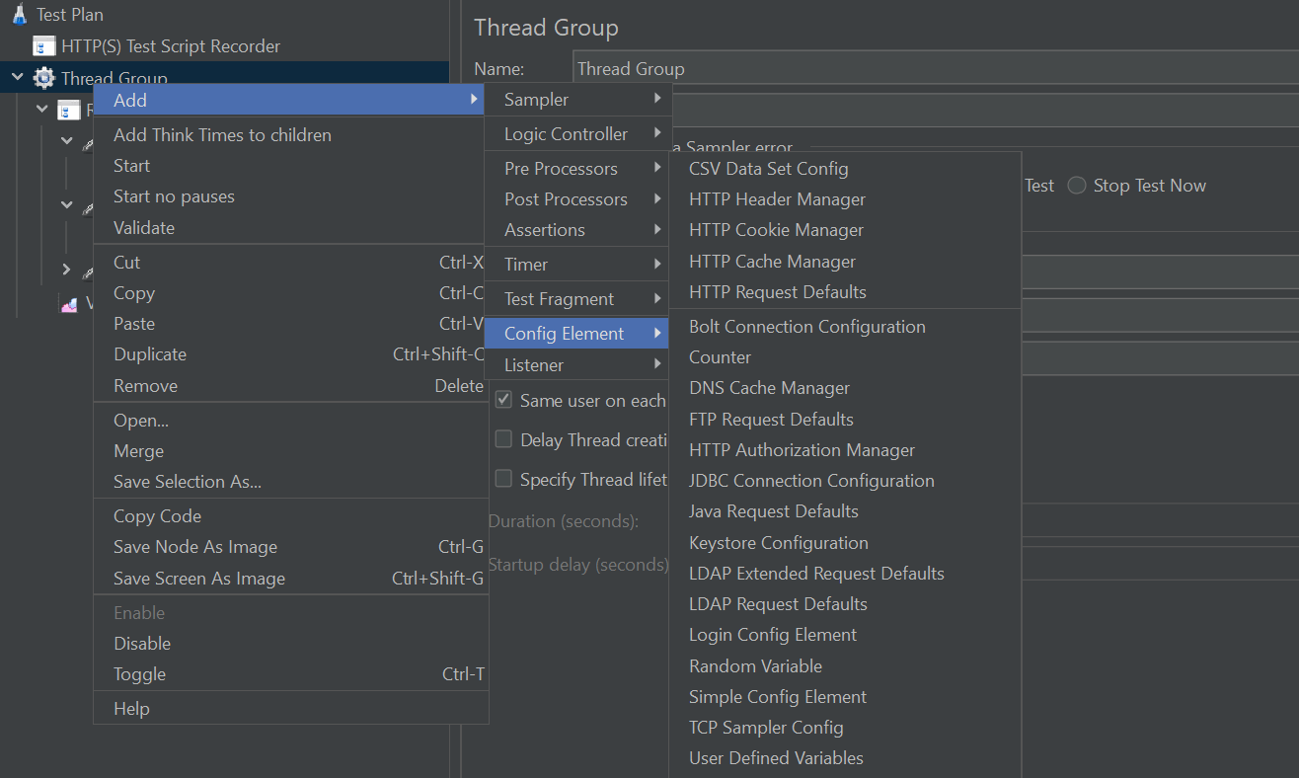

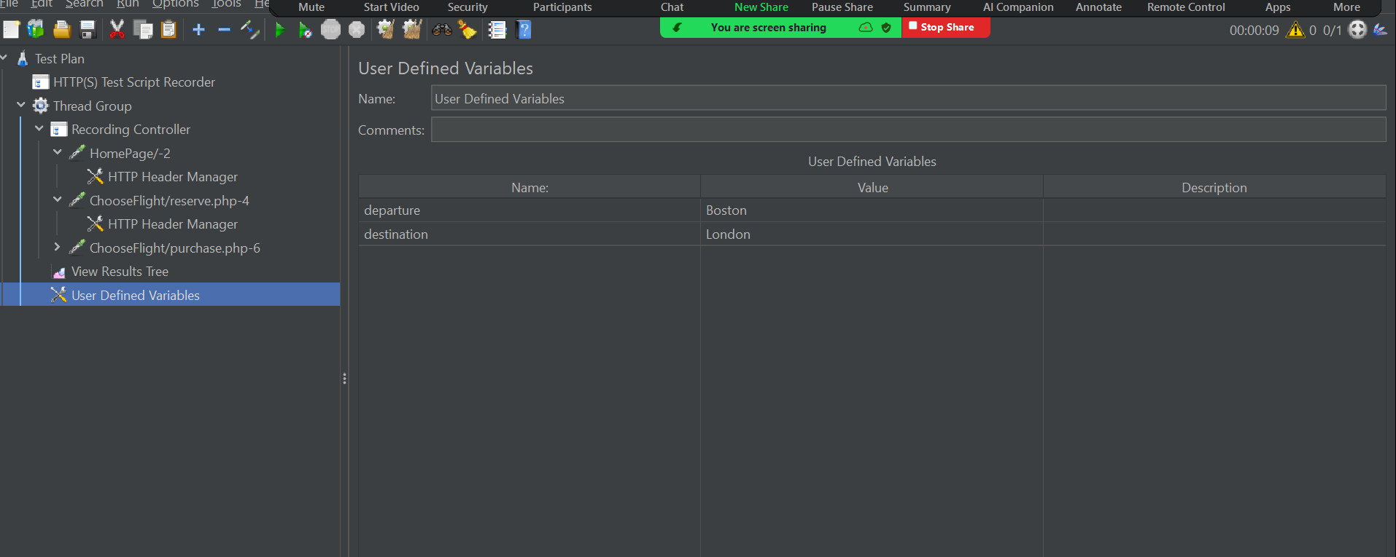

Go to the sampler where we have to pass the variables:

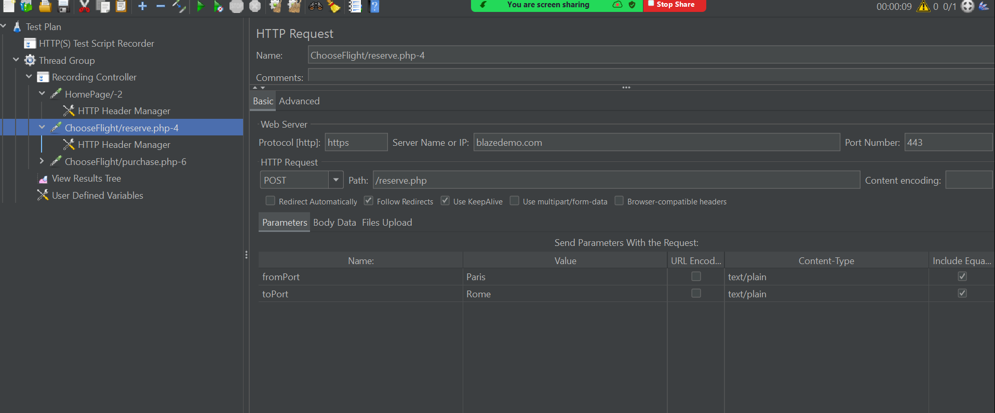

Call the variables in sampler as given below

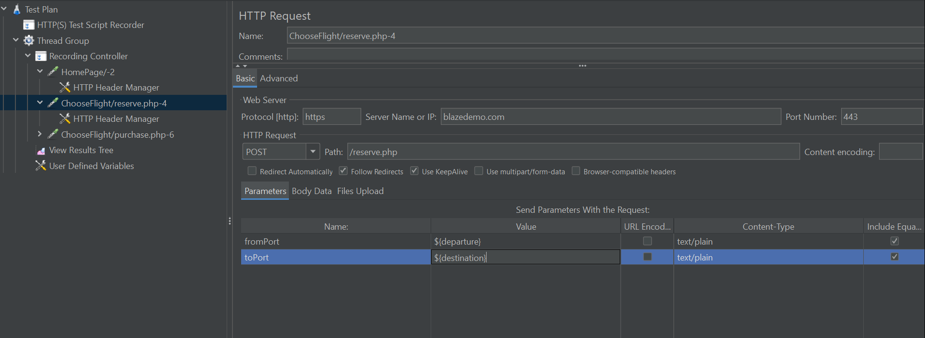

Add view results tree and click on run

